

Department of Cybernetics

School Of Computer Science

UNIVERSITY OF PETROLEUM & ENERGY STUDIES,

DEHRADUN- 248007. Uttarakhand

SOFTWARE REQUIREMENTS SPECIFICATION

For

**AUTOMOBILE LODGING ADMINISTRATION**

Prepared by

|  |  |  |
| --- | --- | --- |
| **SPECIALIZATION** | **SAP ID** | **NAME** |
| Btech. CSE (CCVT) | 500075195 | AKANSH VERMA |
| Btech. CSE (CCVT) | 500075907 | AYUSH KANWAR |
| Btech. CSE (CCVT) | 500076136 | AVIRAL MEHRA |
| Btech. CSE (CCVT) | 500077157 | AMRESH GARG |

Table of Contents

|  |  |  |
| --- | --- | --- |
| **Topic** | | **Page No** |
| 1 | Introduction |  |
|  | 1.1 Purpose of the Project | 3 |
|  | 1.2 Target Beneficiary | 3 |
|  | 1.3 Project Scope | 3 |
|  | 1.4 References | 3 |
| 2 | Project Description |  |
|  | 2.1 Reference Algorithm | 4 |
|  | 2.2 Data/ Data structure | 4 |
|  | 2.3 SWOT Analysis | 5 |
|  | 2.4 Project Features | 5 |
|  | 2.5 User Classes and Characteristics | 5 |
|  | 2.6 Design and Implementation Constraints | 5 |
|  | 2.7 Design diagrams | 6 |
| 3 | System Requirements |  |
|  | 3.1 User Interface | 6 |
|  | 3.2 Software Interface | 6 |
|  | 3.3 Database Interface | 6 |
| 4 | Non-functional Requirements |  |
|  | 4.1 Performance requirements | 7 |
|  | 4.2 Security requirements | 7 |
|  | 4.3 Software Quality Attributes | 7 |

**INTRODUCTION**

**Purpose of the Project:**

Different procedures and measures are being taken currently for parking vehicles in a parking space, but they require a lot of manpower. Our project is based on Graph Data structure where all parking spaces would be interconnected and the user would have two entities, a 5-seater vehicle and a 7-seater vehicle. We would be using Dijkstra's algorithm to find the shortest path to store vehicles in the parking lot.

**Target Beneficiary:**

Because of the expansion in the quantity of vehicles out and about, traffic issues will undoubtedly exist. This is because of the way that the current transportation framework and vehicle leave office created can't adapt to the flood of vehicles out and about. To lighten the previously mentioned issues, the auto housing organization has been created. With the execution of the car dwelling regulatory framework, clients can undoubtedly find and secure an empty parking spot at any vehicle leave considered advantageous to them.

**Project Scope:**

As we as a whole realize that the world is propelling step by step new advancements go back and forth, numerous new strategies are been presented practically day by day, accordingly, the interest of the new frameworks have been expanded in each association, old frameworks have been supplanted by new frameworks, the inquiry is the reason? This is on the grounds that each association requests great quality work and more benefit to be acquired in limited ability to focus time, to acquire as much market trust as possible, and not to forget as speedy they can so they can finish with different associations. New frameworks ought to be: -

1. Easy to understand

2. More Efficient

3. They ought to give security

4. Quick

As these four are referenced, our thought will be founded on these.

**References:**

1. How To Implement Graph Data Structure In Java (softwaretestinghelp.com)

2. Graph Data Structure and Algorithms - GeeksforGeeks

**Project Description**

**Reference Algorithm:**

In solving problems in automobile parking networks Graph theory is a fundamental tool. The term graph in data structure has two different meaning. One is the graph of a function or the graph of a relation. The second usually related to “graph theory‟ is a collection of “vertices” and “links” or “edges”. Graph theory has been closely tied to its applications and its use first can be credited to lodging cars followed by its application to other fields. In automobile lodging, graph theory is most commonly used to study problems.

Graphs are used to model situation in which a commodity is transported from one location to another (from one node to another).

With Dijkstra's Algorithm, you can find the shortest path between the nodes in a graph. You can also **find the shortest path from a node to all other nodes in the graph**, producing a shortest-path tree.

This calculation is used in GPS gadgets to track down the briefest way between the current area and the objective. It has wide applications in industry, particularly in areas that require displaying networks.

**Characteristic of Data:**

1.Graph Theory: A Graph is a non-linear data structure consisting of nodes and edges. The nodes are also referred to as vertices and the edges are lines that connect two nodes in the graph.

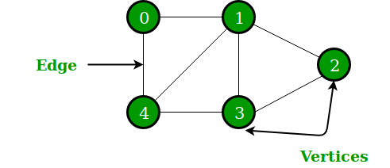

Image Source: https://www.geeksforgeeks.org/wp-content/uploads/undirectedgraph.png

**In the above Graph, vertices V = {0,1,2,3,4} and edges E = {01, 12, 23, 34, 04, 14, 13}**

**Graphs are used to represent networks.**

## 2. Dijkstra’s Algorithm:

For example, if you are provided with a graph of nodes where every node is linked to several other nodes with varying distance. On the off chance that you start from one of the hubs in the diagram, what is the briefest way to each and every hub in the chart?

**Well,**an algorithm that is used for finding the shortest distance, or path, from starting node to ending node in a weighted graph is known as Dijkstra’s Algorithm.

This algorithm makes a tree of the shortest path from the starting node, also called the source, to all other nodes in the graph.

Dijkstra's algorithm uses weights of the edges for finding the path that minimizes the total distance among the source node to all other nodes. This algorithm is also called single-source shortest path algorithm.

**SWOT Analysis:**

Advantages of this project in real word: **-**

1. One of the main advantages of it is its little complexity which is almost linear.

2. It can be used to calculate the shortest path between a single node to all other nodes and a single source node to a single destination node by stopping the algorithm once the shortest distance is achieved for the destination node.

3. It only works for directed-, weighted graphs and all edges should have non-negative values.

Disadvantages of this project in real word: -

1. It is unable to handle negative edges,

2. As it heads to the acyclic graph, so can’t achieve the accurate shortest path, and

3. Also, there is a need to maintain tracking of vertices, have been visited.

**Project Features:**

1.It works only for connected graphs.

2. The main logic of this algorithm is based on the following formula- dist[r]=min(dist[r], dist[q]+cost[q])

This formula states that distance vertex r, which is adjacent to vertex q, will be updated if and only if the value of dist[q]+cost[q] is less than dist[r]. Here-

dist is a 1-D array which, at every step, keeps track of the shortest distance from source vertex to all other vertices, and cost representing the cost adjacency list for the graph

3. The process continues until all the nodes in the graph have been added to the path.

**Design diagrams:**

Use-Case Diagram

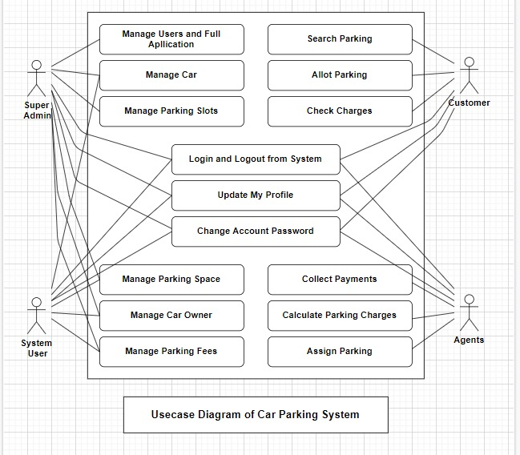

Data Flow Diagram

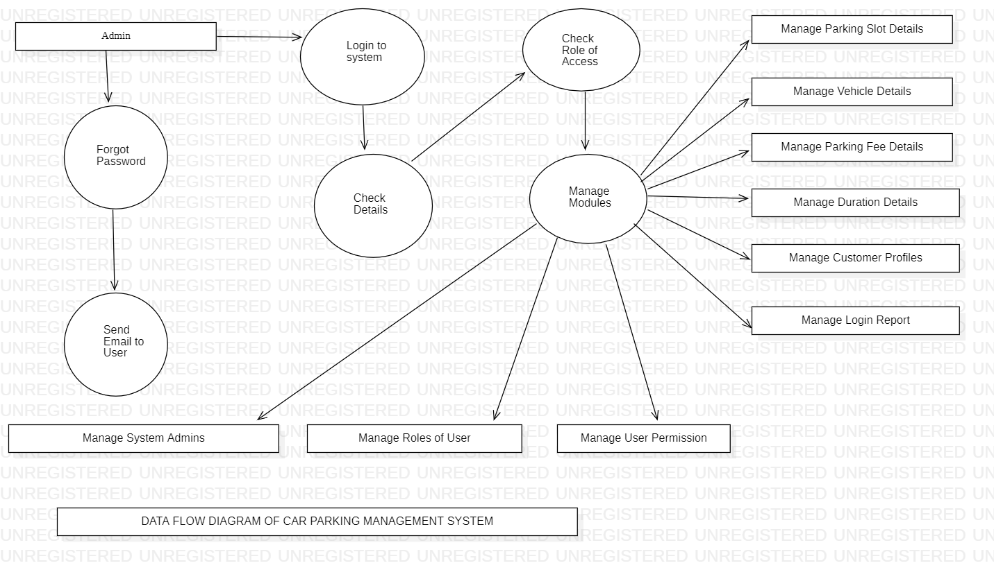

**SYSTEM REQUIREMENTS**

**User Interface:**

The Infrared (IR) sensor nodes senses the status of the car space and transfers the information to a controller. There by displays the information on mobile phone with which the user can check for empty vehicle slots, in turn reducing his time. Client is furnished with an intuitive based UI for the course of pre-booking of stopping space. Client demands the server for areas where stopping is accessible and the server reacts with spaces accessibility.

**NON-FUNCTIONAL REQUIREMENTS**

**Performance requirements:**

1. Admin should have the option to define new stopping regions, determine a scope of parking areas, the stopping cost each moment/hour, and different subtleties.

2. Admin should have the option to refresh information of existing stopping regions.

3. Admin should have the option to see the data of all enlisted stopping regions.

4. The leaving administrator should have the option to send the vehicle plate number and reservation secret key (Session ID) to a central server for confirmation once clients check in.

5. Parking administrator should have the option to Issue bills to clients on checkout.

6. User should have the option to Register for the assistance and enter individual and vehicle details.

7. User should have the option to discover a stopping region from the rundown of regions, enlisted by stopping administrators.

8. User should have the option to see the details of a stopping region like the name, worth each moment, number of absolute accessible parts.

9. The client should have the option to Reserve a reachable parking spot and indicate the term of the booking.

The framework reaction time for each guidance directed by the client should not surpass in excess of at least 10 seconds. The framework ought to have elite rate when executing client's feedback and ought to have the option to give reaction inside a brief time frame range typically 50 second for exceptionally convoluted assignment and 20 to 25 seconds for less confounded undertaking

**Security requirements:**

Security and protection are the two most significant parts of having a stopping the executives framework. In contrast to the customary way, the framework inserted with the furthest down the line innovation can keep a beware of every single vehicle entering and leaving the premises. The framework gives username and secret key to keep the framework from unapproved access. The staffs' secret key should be more noteworthy than eight characters. The subsystem will give a significant degree of safety and trustworthiness of the information held by the framework, just approved work force of the organization can access the organization's gotten page on the framework; and just clients with legitimate secret word and username can login to see client's page.

**Software Quality Attributes:**

1. Availability: The framework will consistently be accessible for access at 24 hours, 7 days per week. Additionally, in the event of any significant framework failing, the framework will be accessible in 1 to 2 working days, so business process isn't seriously influenced.

2. Maintainability: Error will be impressively limited and a fitting blunder message that directs the client to recuperate from a mistake ought to be given. Approval of client's feedback is profoundly fundamental. Additionally, the standard time taken to recuperate from a blunder will be 15 to 20 seconds.

3. Flexibility: A straightforward however quality UI will be created to make it straightforward and require less preparing.

4. Usability: This specific framework is of prevalent quality and easy to use.

END